[](http://thehub.royallondongroup.com/)

 

Test Approach

ThinkBeyond BI Project

version 1.0

VERSION CONTROL

|  |  |  |  |  |
| --- | --- | --- | --- | --- |
| Version | Date | Author | Comment | Changes Marked? |
| Draft | 09/04/2018 | Shiva Prasad | First Draft version for review | No |
| Version 0.1 | 11/05/2018 | Shiva Prasad | Updated as per review comments from Mark and Fraser | No |
| Version 0.2 | 21/05/2018 | Shiva Prasad | Updates a per TTL Walk through review comments | No |
| Version 0.3 | 04/07/2018 | Shiva Prasad | Updated as per the SIT/NFT/UAT/OAT team comments | No |
| Version 0.4 | 13/07/2018 | Shiva Prasad | Updated SIT Test Gates and approach | No |
| Version 1.0 | 13/07/2018 | Shiva Prasad | Signed Off | No |

SIGN-OFF

|  |  |  |
| --- | --- | --- |
| Action | People | Date Completed |
| Heat map peer reviewed by AP and BA Leads and Solution Architect | Lise Parker(SA), Richard Brown(AP), John Drummond (BA), Ada Chereches (AP) | NA |
| Initial draft issued to internal project team for peer review | #TB – BI Team | 10/04/2018 |
| Peer reviewed | #TB TTL - Fraser Robertson, Mark Bailie | In Progress |
| Final draft issued to full project team | Lise Parker(SA), Richard Brown(AP), John Drummond (BA), Fraser Stark (AP), Jonathan Miller (TA), Sathyanath (TA) |  |
| Walkthrough with project team | Lise Parker(SA), Richard Brown(AP), John Drummond (BA), Fraser Stark (AP), Jonathan Miller (TA), Sathyanath (TA) |  |
| Sign off | Pamela Aitken (PM)  Lise Parker(SA)  Richard Brown(LAP)  Mackinnon AJ (TM)  Fraser Robertson (TTL)  Mark Bailie(TTL)  Kevin Harrigan (ITL)  Anthony Conway ( TTL Lead) |  |

DISTRIBUTION

|  |  |
| --- | --- |
| Name | Role |
| Joanne Vincent | STS Manager |
| Fraser Stark | Analyst Programmer |
| Fraser Robertson | Test Team Lead |
| Richard Brown | Lead Analyst Programmer |
| Lise Parker | BI Workstream Lead / Solutions Architect |
| Pamela Aitken | Project Manager |
| Mackinnon AJ | Programme Test Manager |
| John Drummond | Lead BI Technical Analyst |
| Jonathan Miller | #ThinkBeyond BI Test Analyst |
| Sathyanath Selvaraj | #ThinkBeyond BI Test Analyst |
| Keira Price | #ThinkBeyond Test Team Lead |
| Kevin Harrigan | #ThinkBeyond Integrtaion Test Lead |
| Malcolm While | NFR Lead |
| Yashovardhan Bhomia | SIT Execution Test Lead |
| Ed Murphy | #ThinkBeyond CJ Test Lead |
| Kirstin Forder | #ThinkBeyond Sonata Test Lead |
| Meera Raina | #ThinkBeyond API Test Lead |
| Ankhur Sekhri | #ThinkBeyond CRM Test Lead |
| Anthony Conway | #ThinkBeyond SIT Test Lead |
| Richard Rose | AOE Test Lead |
| Mark Baillie | #ThinkBeyond Migration Test Lead |
| Priya Nallamuthu | #ThinkBeyond PCIT Lead |
| Helene Salaün | #ThinkBeyond UAT Lead |
| Umran Khan | #ThinkBeyond NFT Lead |
| Kevin Bradley | #ThinkBeyond OAT lead |
| Jamie Turnbull | #ThinkBeyond TTL QA Reviewer |
| Lorraine Lamy | #ThinkBeyond Release Management |
| Nicola Booty | #ThinkBeyond Test Control Support |
| IT Security | IT Security Group |
| Pradeep Chadalawada | #ThinkBeyond Test Team Lead |
| Shikha Chauhan | #ThinkBeyond Test Team Lead |
| John Fowler | #ThinkBeyond Test Team Lead |
| Parul Garg | #ThinkBeyond Test Team Lead |
| Rahul Gaur | #ThinkBeyond Test Team Lead |
| Hitesh Goyal | #ThinkBeyond Test Team Lead |
| Heemanshu Gupta | #ThinkBeyond Test Team Lead |
| Sachin Khurana | #ThinkBeyond Test Team Lead |
| Krishna Kumaaran | #ThinkBeyond Test Team Lead |
| Nimisha Mathew | #ThinkBeyond Test Team Lead |
| Krishna Prabhu | #ThinkBeyond Test Team Lead |
| Kavitha Raghu | #ThinkBeyond Test Team Lead |
| Justin Raj | #ThinkBeyond Test Team Lead |
| Arunagiri Satish | #ThinkBeyond Test Team Lead |
| Ankur Sekhri | #ThinkBeyond Test Team Lead |
| Ankur Sharma | #ThinkBeyond Test Team Lead |
| Ramita Singh | #ThinkBeyond Test Team Lead |
| Shekar Srinivasan | #ThinkBeyond Test Team Lead |
| Anuradha Suri | #ThinkBeyond Test Team Lead |
| Prasanna Thandabani | #ThinkBeyond Test Team Lead |
| Craig Thompson | #ThinkBeyond Test Team Lead |

REFERENCES

|  |  |
| --- | --- |
| **Document** | **Source / Location** |
| Business Requirements | <http://rliprojects-portal/programme/scottishlife/ThinkBeyond/BI/Project%20Documents/1.%20Business%20Requirements/BI%20Business%20Requirements.docx> |
| Non-functional Requirements | [http://rliprojects-portal/programme/scottishlife/ThinkBeyond/Project%20Documents/2.%20Solution%20Design/01%20Tech%20Arch%20Design%20and%20Governance/15%20NFR%20team/RL%20TB%20NFR%20Iteration%201%20v1.0%20Final.docx](http://rliprojects-portal/programme/scottishlife/ThinkBeyond/Project%20Documents/2.%20Solution%20Design/01%20Tech%20Arch%20Design%20and%20Governance/15%20NFR%20team/NFR%20Archive/RL%20TB%20NFR%20Iteration%201%20v1.0%20Final.docx) |
| Application Design | [http://rliprojects-portal/programme/scottishlife/ThinkBeyond/BI/Project%20Documents/2.%20Solution%20Design/Technical%20Design/ThinkBeyond%20BI%20Solution%20Design.docx](http://rliprojects-portal/programme/scottishlife/ThinkBeyond/BI/Project%20Documents/2.%20Solution%20Design/Archive/Technical%20Design/ThinkBeyond%20BI%20Solution%20Design.docx) |
| Microsoft Test Manager Standards | [MTM Guide](http://rliprojects-portal/standards/testing/Shared%20Documents/Microsoft%20Test%20Manager/MTM%20guide.docx) |
| #Think Beyond Test Strategy (OTS) | [#Think Beyond Test Strategy](http://rliprojects-portal/programme/scottishlife/ThinkBeyond/Project%20Documents/4.%20Testing/Test%20Strategy/tb%20Programme%20Test%20Strategy/thinkbeyond%20Programme%20Test%20Strategy%20v1.2.docx) |
| #Think Beyond – Operational Extracts Test Approach | <#Think Beyond – Operational Extracts Test Approach> |
| Project Definition Document | [http://rliprojects-portal/programme/scottishlife/ThinkBeyond/BI/Project%20Documents/0.%20Project%20Management/Project%20Definition%20Document.doc](http://rliprojects-portal/programme/scottishlife/ThinkBeyond/BI/Project%20Documents/Project%20Management/Archive/Project%20Definition%20Document.doc) |
| Environments | [http://rliprojects-portal/programme/scottishlife/ThinkBeyond/BI/Project%20Documents/2.%20Solution%20Design/Environments.pdf](http://rliprojects-portal/programme/scottishlife/ThinkBeyond/BI/Project%20Documents/2.%20Solution%20Design/Archive/Environments.pdf) |
| Test Gates | <http://rliprojects-portal/programme/scottishlife/ThinkBeyond/Project%20Documents/Forms/AllItems.aspx?RootFolder=http%3a%2f%2frliprojects%2dportal%2fprogramme%2fscottishlife%2fThinkBeyond%2fProject%20Documents%2f4%2e%20Testing%2f1%2e%20Test%20Governance%2f01%20Test%20Gates&FolderCTID=0x01200047B6D631674D564C97AEEA3B2BB6F920> |

**CONTENTS**

1 INTRODUCTION 8

1.1 Background 8

1.2 Purpose 8

2 PROJECT SCOPE 9

2.1 In scope 10

2.2 Out of scope 10

3 Test approach 11

3.1 V Model or Agile 11

3.2 Approach and Techniques 12

3.3 Cross Browser and Device Testing 16

3.4 Performance Testing 16

3.5 Onshore/Offshore Testing 16

3.6 Calculations Testing 16

3.7 Security Testing 16

3.8 Test Phases and Objectives 17

3.9 Test Releases and Cycles 19

3.10 Test Pack 19

3.11 Testing Types/Techniques 20

4 Risk Assessment 21

4.1 Quality Assurance 21

4.2 RAIDs 21

5 Test Data 21

5.1 Data Requirements 21

5.2 Data Population 22

6 Management & Quality Controls 22

6.1 Roles and Responsibilities: 22

6.2 Skills and Resource Requirements 22

6.3 Reporting 23

6.3.1 Progress Reporting 23

6.3.2 Test Completion Report 23

6.4 Microsoft Test Manager 23

6.4.1 Quality Criteria 23

6.4.2 Reviews 24

6.5 Communication/Meetings 24

6.6 Handover to Support 24

7 Glossary 25

# INTRODUCTION

## Background

The Group BI platform was introduced for the D2C business in 2014, and has since been extended to include data for GCS, Protection and Solvency II. The current provision of BI in Intermediary Pensions is via operational fat file extracts that are re-purposed and manipulated to produce BI. This manual process is labour intensive, and risks errors and inconsistencies.

#ThinkBeyond BI provides an opportunity to improve the availability and use of data for decision making within the Pensions business.

#ThinkBeyond programme will replace the current pension administration system (Oryx) with a new Pensions platform, which primarily consists of: Sonata (policy administration), Dynamics 365 (customer management), Sales Management, and Investment Control and Intermediary Management systems.

The Group BI platform is extended to make relevant data from the new Pensions platform available to the business. The as-is BI reporting will continue to be produced with ingestion of existing data to new BI platform but however the existing operational reports like-for-like will not be replicated, but will introduce self-service BI for stakeholders in RLI Pensions, and from Customer Journey teams.

## Purpose

The purpose of this document is to communicate the detailed approach to be followed, understand and agree the scope, the objectives, the resources and responsibilities and the activities/processes that will be followed in order to conduct a controlled and repeatable test for successful assurance of the quality to be implemented in the #ThinkBeyond BI Project.

In line with the guidance from the #ThinkBeyond Programme test strategy, the #ThinkBeyond-BI Test Plan and approach document will:

* Highlight the testing objectives, the testing in-scope/out-of-scope features and corresponding components to clearly understand what needs to be tested;
* Detail the types of testing (e.g. System test, Integration, UAT) that will be conducted to ensure clarity on how relevant phases will be tested
* Demonstrate an overall testing process that ensures the whole #ThinkBeyond BI Platform is tested to the degree required for business to accept the delivered system into services
* Outline how the test approach will be followed to ensure all parties understand the testing stages and corresponding timelines;
* Documents the clarity on the roles and responsibilities throughout the testing stages
* Lists the environment and test tools in consideration

The document will form an overarching plan for subsequent development phase of enhancement in #TB – BI project alone. With any changes to the #TB – BI Test plan, the details specific to each enhancements captured in addendums to this document.

# PROJECT SCOPE

The #ThinkBeyond Business Intelligence project is aimed at providing a centralized platform supporting all business intelligence and advanced analytics needs across the group.

The BI work stream will be responsible for driving the implementation of operational data repository (ODR) sourced from cloned data sources to deliver the Enterprise Data Warehouse (EDW) solution.

The architectural design for #ThinkBeyond - BI is as shown below.

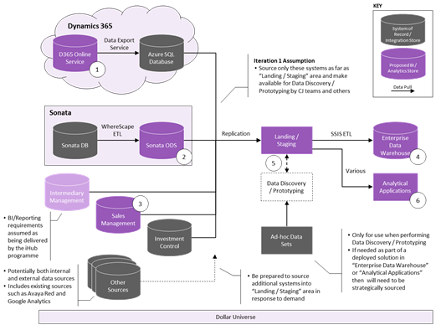

The data flow to ODR – EDW – Pensions Catalog (Presentation Layer) – Self Service BI as depicted below:

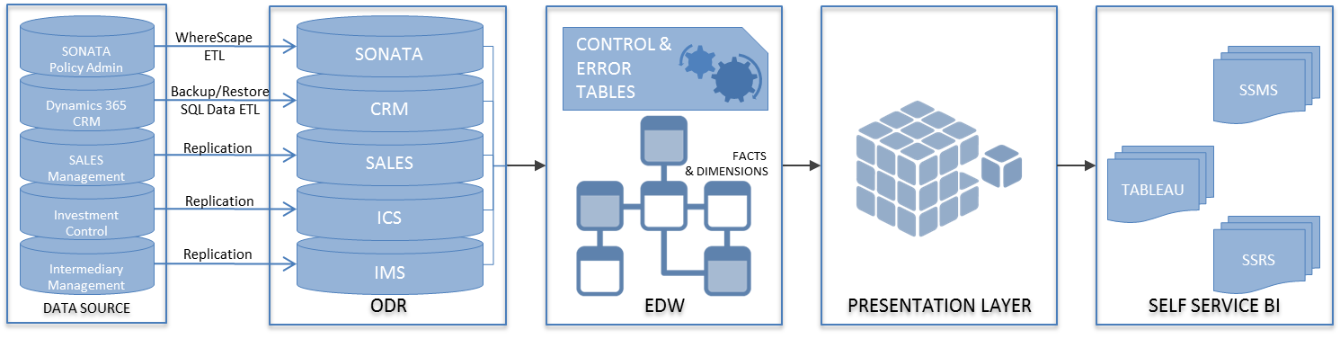

## In scope

The following items are within the scope of the #ThinkBeyond – BI Project:

|  |  |
| --- | --- |
| **Area** | **Description** |
| Operational Data Repository | Host data from key data sources.   * Dynamics CRM365 * Sonata * Sales Management * Investment Control System * Intermediary Management Hub |
| Enterprise Datawarehouse | Integration Services pull necessary data attributes (transformed where applicable) from the operational data repository with a master package for each business unit controlling the execution of services for the corresponding business unit. |
| Pensions Catalog | Load and present views which query data from the facts and dimensions in EDW to enable users to select only data pertaining to the pension’s business unit, via ‘business division’ and ‘business line’ fields on the facts and dimensions tables. |
| Self Service BI | The reporting services SSRS, Tableau and SSMS enable user to gain data insight of the Enterprise Datawarehouse for decision making. |
| Operational Extracts | Build and Implement operational reports. Please refer Operation Extracts Plan here for more details. |

## Out of scope

The following items are Out of Scope for the #ThinkBeyond – BI Project:

|  |  |  |
| --- | --- | --- |
| **Area** | **Description** | **Reason not in Scope** |
| Data Source | The Sonata ODS, Dynamic 365. Sales Management, Investment Control System, Intermediary Management Hub data ingestion and data authentication is out of scope. | The corresponding team of each Source system will be responsible for data ingestion and assuring the quality of data. |
| Data Dictionary | Management of #Think Beyond Data Dictionary is out of scope. |  |
| Cross Browser Testing | Cross browser testing is not application in #TB – BI Arena | No requirement to perform cross browser testing |

# Test approach

## V Model or Agile

This project will use the Agile project management method for Unit and CIT (Code Integration Testing).

The V Model approach will be followed from then on, i.e. for Integration and Pre-Production testing.

In Agile testing the #TB-BI test team will actively contribute in planning and requirement analysis and to user story improvements.

Before the start of testing, the development team’s detailed design documents must be approved so that test case creation can start. Both coding and testing are performed incrementally and iteratively in Sprints, building each feature until it delivers enough stability and adds quality to the product. While the development team starts the implementation of modules (in the very first Sprint), the QA team begins work on the test case design. The drafted test scenarios are handed over to the project business analyst, architect and lead programmer and any stakeholder from the business side to review. This is to ensure that test coverage is as complete as possible.

The below diagram provides a blue print of Unit and System Testing/CIT test methodology in #ThinkBeyond – BI project:

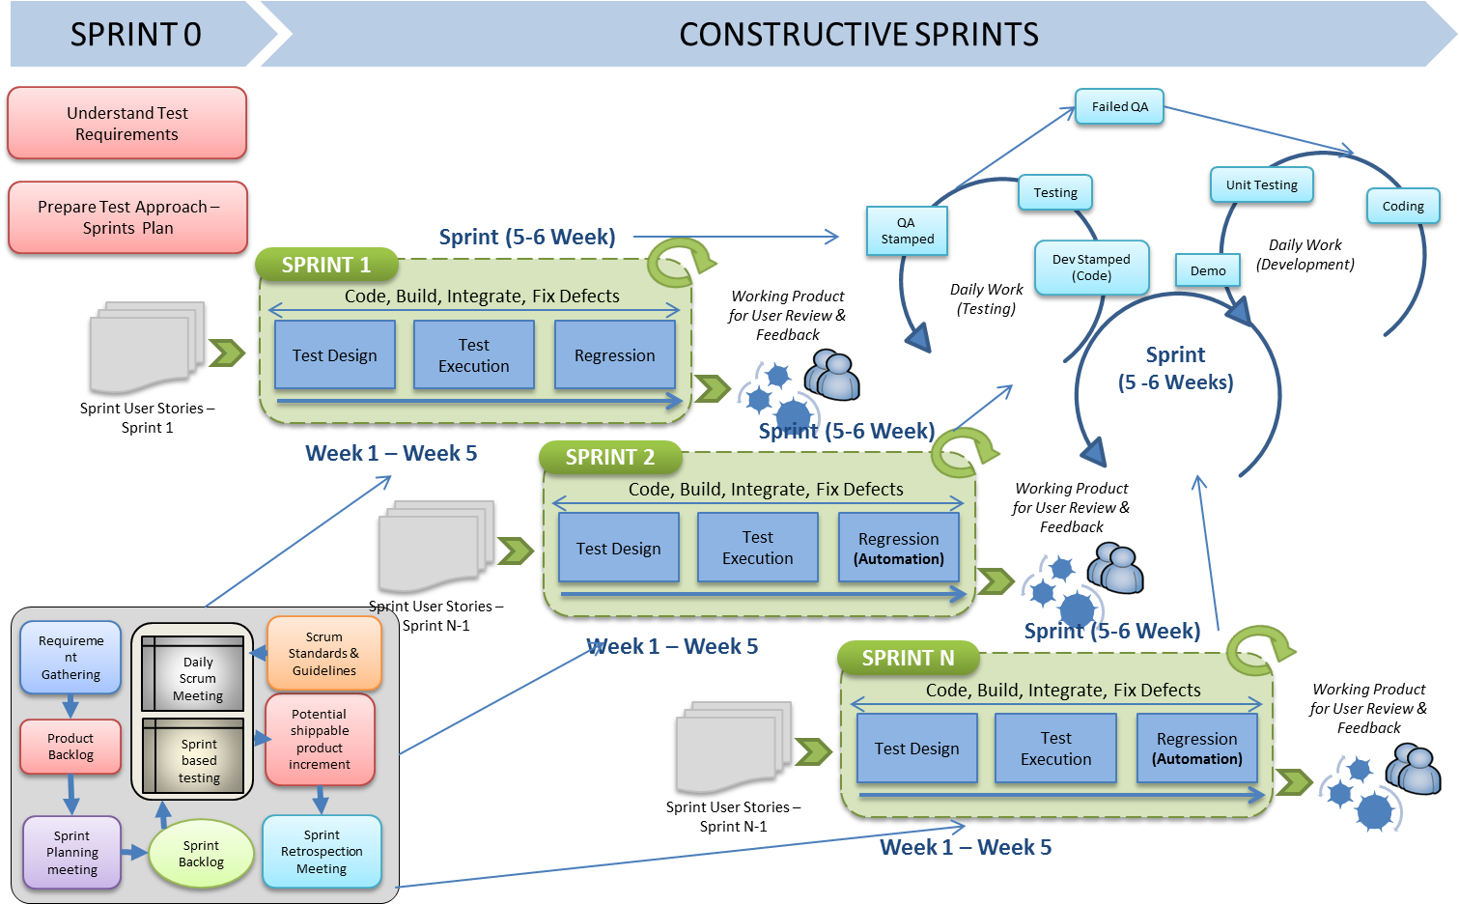

When code is ready to test (after the end of each Sprint), QA works with development to execute test cases on the CIT environment, in order to identify the early stage defects so developers can fix them during the next round, on a priority basis. This process is then repeated throughout the development process.

The aim is to facilitate the teams to work collaboratively with the AP and BA and perform testing from early stages of the project to find bugs up front and ensure code is thoroughly tested before deployment to the project CIT environment. The aim should be to have the unit test and system/CIT test completed and signed off within the sprint before code deployment to SIT environment.

In V-Model approach, the #TB-BI team will collaboratively work with SIT, NFT, UAT and Pre-Production test team in performing verification and validation of the code in SIT and pre-prod environment. The #TB SIT team will be responsible to provide required test data (if any - as per Test Scenarios requirements) for #TB BI SIT Testing and ensure data quality and integration with Upstream systems is intact. Each team will individually verify and validate data functionality in their respective systems to ensure end to end data functionality is intact.

The SIT and Pre-Prod approach will subject to further discussion and may undergo further changes in ways of working. <WIP>

The #TB-BI team will provide necessary support and details for NFT and UAT testing. The NFT and UAT approach will subject to further discussion and may undergo further changes in ways of working. <WIP>

## Approach and Techniques

The test approach for #ThinkBeyond BI project will follow a layer based QA ensuring data across each layer is as per the business requirements and meets the system criteria. Below is the layer based approach and the QA Check points validated across each layer followed;

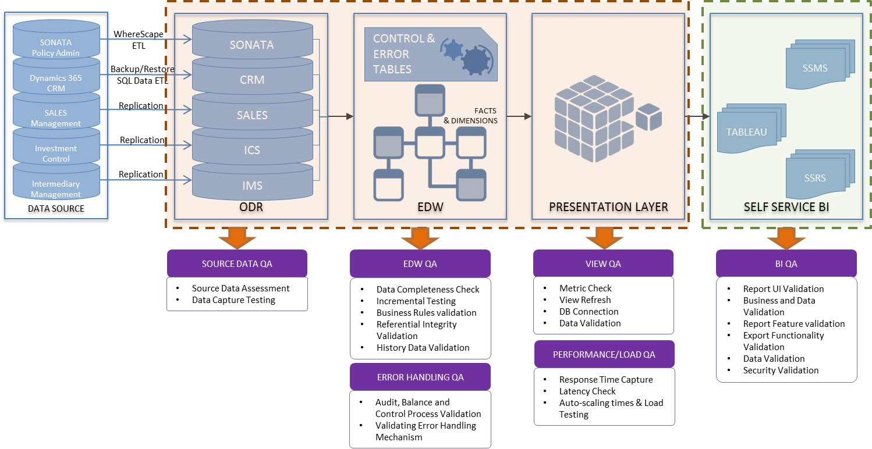

The test execution in each sprint is carried in 2 sequences:

* Initial Data Load
* Incremental Data Load

At end of every sprint, the regression suite is built and the same would be executed in the successive sprints.

The Unit Test and CIT phase will be conducted –

Automation - The regression SQL test scripts will be bundled into stored procedures and executed as a test package after every sprint. The stored procedure based semi-automated test scripts will be under continuous improvisation to achieve increased automation benefits. The automation technique to be employed will be a WIP activity (as currently the BI team is evaluating potential automation tools) with close evaluation and feedback in every sprint to achieve 100% automation.

The below diagram depicts the test activities performed in the CIT phase:

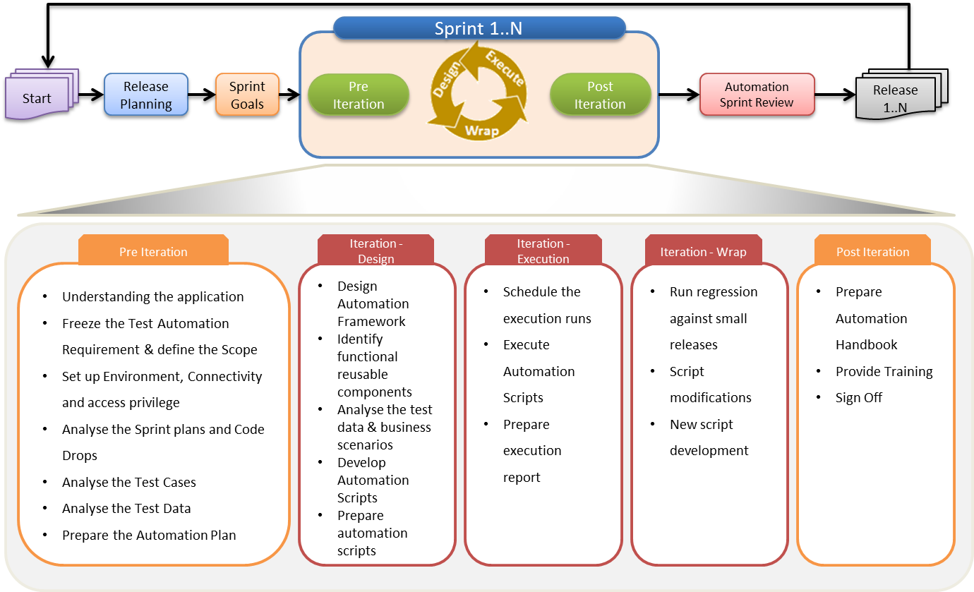

The testing in #ThinkBeyond – BI project will follow through the test phases as shown in the below diagram:

The #TB-BI SIT will be conducted in collaboration with #TB-SIT team in the respective SIT environment.

Below diagram reflects the SIT approach.

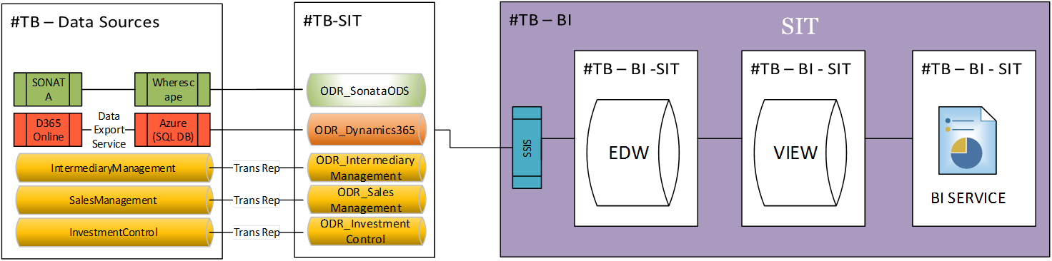

The below table details the activities performed to during SIT;

| Criteria | Tasks | OWNER | |
| --- | --- | --- | --- |
| BI | SIT |
| Pre-Requisites | Environment build & configuration complete | #TB - BI : ONLY FOR BI PLATFORM | #TB - SIT : ODR SIT Env |
| Pre-Requisites | Code deployment and deployment checks complete | #TB - BI : ONLY FOR BI PLATFORM | N/A |
| Pre-Requisites | Release notes delivered | #TB - BI : ONLY FOR BI PLATFORM | N/A |
| Pre-Requisites | Design is complete | #TB - BI : ONLY FOR BI PLATFORM | N/A |
| Pre-Requisites | Scope' has been defined | #TB - BI : ONLY FOR BI PLATFORM | N/A |
| Support | Resource names & availability confirmed for Environment Support (Engineering) | #TB - BI : ONLY FOR BI PLATFORM | #TB-SIT (Anthony) /Engineering |
| Support | Resource names & availability confirmed for Defect Triage & remediation | #TB - BI : ONLY FOR BI PLATFORM | #TB-SIT (Anthony) /Engineering |
| Support | Schedule agreed for defect remediation | #TB - BI : ONLY FOR BI PLATFORM | #TB-SIT (Anthony) /Engineering |
| Readiness | Environment Access verified | #TB - BI : ONLY FOR BI PLATFORM | #TB - SIT : ODR SIT Env |
| Readiness | Test Data/Files created where requested | #TB – SIT | |
| Test Planning | Test Approach has been approved | #TB - BI : ONLY FOR BI PLATFORM | N/A |
| Test Planning | Test Plan has been approved | #TB - BI : ONLY FOR BI PLATFORM | N/A |
| Test Planning | Testing Risk Assessment has been undertaken and agreed | #TB - BI : ONLY FOR BI PLATFORM | N/A |
| Readiness | TFS/MTM Test Structure is complete | #TB - BI : ONLY FOR BI PLATFORM | #TB-SIT (Anthony) |
| Readiness | Test Conditions/Acceptance Criteria have been defined | #TB - BI is alone responsible for test acceptance criteria | |
| Readiness | Test Scenarios/Test Cases have been approved | TB BI to share scenarios to #TB-SIT (Anthony) for approval and confirm the required data availablity for the same. | |
| Readiness | Manual Tests have been prepared | #TB - BI : ONLY FOR BI PLATFORM | #TB-SIT (Anthony) |
| Readiness | Automation Tests have been created | #TB - BI : ONLY FOR BI PLATFORM | #TB-SIT (Anthony) |
| Readiness | Execution Schedule is in place | #TB - BI : ONLY FOR BI PLATFORM | #TB-SIT (Anthony) /Engineering |
| Quality Assurance | Test Planning is complete (and agreed QA levels achieved) | #TB - BI : ONLY FOR BI PLATFORM | N/A |
| Quality Assurance | Test Analysis & Design is complete (and agreed QA levels achieved) | #TB - BI : ONLY FOR BI PLATFORM | #TB-SIT (Anthony) |

For the #TB – BI SIT the execution schedule, the BI team is dependant on #TB-SIT team to schedule and execute wherescape ETL and CRM data refresh.

As defined by #TB Programme Test Strategy for delivering distinct drops of functionality into SIT, a formal Testing Gate that will be established per planned drop to assess CIT Exit Criteria and SIT Entry Criteria.

The formal gate will make a Decision will be made based on the following:

* Where exit and entry criteria all pass - Decision to pass gate and enter in to the subsequent phase with no remedial action by either party
* Where exit criteria fail and entry criteria pass - Decision to proceed through the gate and enter in to the subsequent phase may be made with formal risks documented and remedial action plan put in place by the initiating phase.
* Where exit criteria pass and entry criteria fail – Decision to proceed through the gate and enter in to the subsequent phase may be made with formal risks documented and remedial action plan put in place by the receiving phase.
* Where exit and entry criteria all fail – Decision to stop may be made and risks documented and remedial action plan put in place by both parties

The informal process of assessing exit / entry criteria w commence 1 Month prior to the intended drop to SIT with weekly assessments, then daily assessments in the last week, leading up to the decision at the formal gate on the completion date for CIT.

Appropriate Risks captured in the relevant RAIDs Log by both #TB BI Team and #TB SIT teams with action plans. Decision Log updated to reflect Decision taken and Test Completion report updated with Risks identified.

Approved Test completion report to be re-issued and Signed off, evidence stored in SharePoint.

Any #TB-BI SIT defects will be logged and test execution monitored in the #TB – BI TFS and MTM portal. If the defect origin lies with the upstream systems (to be discussed and agreed as part of daily defect triage), the defect will be logged in #TB-IT TFS accordingly.

The Code drop to SIT is as depicted in the timeline below;

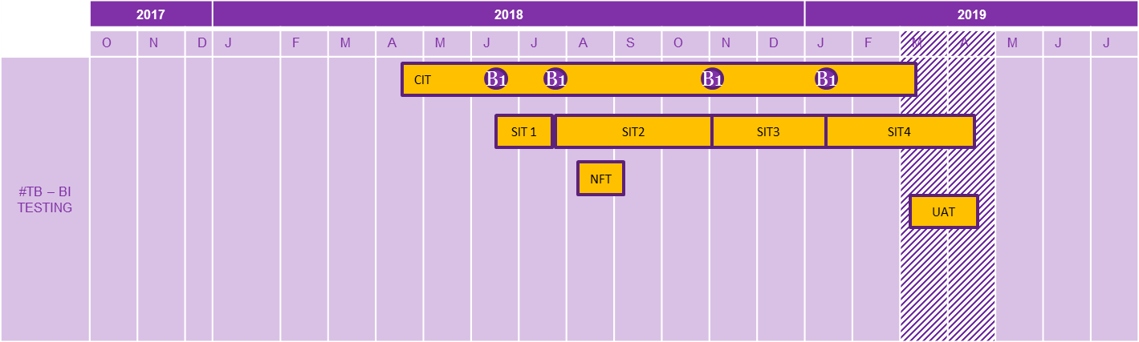

In the SIT phase, the #TB-BI team will execute the regression – automation pack test suite and manual perform validation if any specific scenario based requirement to be tested.

The [*Automation Decision Tree*](http://rliprojects-portal/programme/scottishlife/ThinkBeyond/BI/Project%20Documents/4.%20Testing/Test%20Strategy/RL%20Automation%20Decision%20Tree.docx) referenced for automation justification.

The Performance testing will be conducted in #TB-BI Performance environment by #TB-BI test team. The NFR requirements will be tested with data generated by the #TB NFT team. This phase as dependency on #TB NFT team to provide test data.

The UAT testing will be performed by the business user in the UAT environment. The #TB-BI test team will share/provide required support and test governance.

The Pre-Prod testing will be performed in the Pre-Prod environment by the #TB-BI test team, verifying deployment, batch jobs, and sample data validation.

## Cross Browser and Device Testing

Cross Browser testing is out of scope for #ThinkBeyond – BI Project as data only held in enterprise Datawarehouse is in scope for testing.

## Performance Testing

Performance testing methodology is aligned to the NFR requirements of the #ThinkBeyond – BI project.

The performance testing will performed in the #TB-BI performance environment by the #TB-BI test team.

Please refer the performance test plan <WIP>

## Onshore/Offshore Testing

The #ThinkBeyond – BI project is wholly tested by Onshore team.

## Calculations Testing

No requirement to perform Calculations testing.

## Security Testing

The #Thinkbeyond – BI team will perform Datawarehouse and Views (Pension Catalogue) security testing ensuring the AD level access is right roles and responsibilities.

The Datawarehouse will be validated for row level security ensuring only the business users defined in the security table have access to specific dimensions tables.

The Datawarehouse will be validated for column level security ensuring only the business users defined in the security table have access to sensitive and financial data.

## Test Phases and Objectives

All test phases are mandatory apart from Model Office testing. Business Readiness has assessed this and has determined that MO testing is for the ThinkBeyond BI Project.

|  |  |  |  |
| --- | --- | --- | --- |
| **Requirements Test Phase – Environment n/a** | | | |
| Entry/Exit | Criteria | Owner | Quality Gate Owner |
| Entry | * Requirements documented and reviewed by project team * Requirements prioritised for risk assessment and test planning * Non-functional requirements documented and reviewed by project team | TA | TTL |
| Exit | * Static testing completed on all requirements * Test conditions signed off by project team | TA | TTL |

|  |  |  |  |
| --- | --- | --- | --- |
| **Unit Test Phase – Local Build Environment** | | | |
| Entry/Exit | Criteria | Owner | Quality Gate Owner |
| Entry | Agile   * Requirements signed off by BA * User stories reviewed and signed off by project team * Internal code review completed | AP | Lead AP, TTL |
| Exit | * Unit testing completed and all automated scripts pass * Code peer reviewed | AP | Lead AP, TTL |

|  |  |  |  |
| --- | --- | --- | --- |
| **CIT Phase – Project CIT Environment** | | | |
| Entry/Exit | Criteria | Owner | Quality Gate Owner |
| Entry | * Unit Test exit criteria have been met * Test matrices signed off by project team * Skim test of environment successfully completed * Test Scenarios are signed off by the #TB – BI Project team | TA | TTL |
| Exit | * All test scripts executed * No critical, high or medium priority defects outstanding * Any outstanding low priority defects and/or workarounds agreed by project team | TA | TTL |

|  |  |  |  |
| --- | --- | --- | --- |
| **Integration Test Phase – Project SIT Environment** | | | |
| Entry/Exit | Criteria | Owner | Quality Gate Owner |
| Entry | * CIT exit criteria have been met * Test matrices signed off by project team * Skim test of environment successfully completed | TA | TTL |
| Exit | * All test scripts executed * No critical, high or medium priority defects outstanding * Any outstanding low priority defects and/or workarounds agreed by project team | TA | TTL |

|  |  |  |  |
| --- | --- | --- | --- |
| **Performance Test Phase – Performance Test Environment** | | | |
| Entry/Exit | Criteria | Owner | Quality Gate Owner |
| Entry | * Code has been signed off for deployment to UAT environment * Performance test plan signed off by project team * Performance test scripts signed off by project team * Skim test of environment successfully completed | PTA | PTA, TTL, SA, Lead AP |
| Exit | * All performance scripts executed and all tests pass * No defects outstanding * Test execution signed off by project team | PTA | PTA, TTL, SA, Lead AP |

|  |  |  |  |
| --- | --- | --- | --- |
| **UAT Test Phase – UAT Test Environment** | | | |
| Entry/Exit | Criteria | Owner | Quality Gate Owner |
| Entry | * Integration Test exit criteria met * Skim test of environment successfully completed | TA | Business User |
| Exit | * All test scripts executed and all tests pass * No defects outstanding | TA | Business User |

|  |  |  |  |
| --- | --- | --- | --- |
| **Pre-Production Test Phase – PRE Test Environment** | | | |
| Entry/Exit | Criteria | Owner | Quality Gate Owner |
| Entry | * Integration Test exit criteria met * Performance Test exit criteria met * Confirmation code has been shipped to PRE * Skim test of environment successfully completed | TA | TTL |
| Exit | * All test scripts executed and all tests pass * No defects outstanding | TA | TTL |

## Test Releases and Cycles

Testing undertaken follows W Model utilising iterative agile approach to the inputs to the testing undertanken to the sprint testing phase. Achieving a ‘done’ status for the testing of features being delivered within a sprint and once done the feature is promted to the integration testing.

These releases and cycles will be documented in Microsoft Test Manager.

## Test Pack

The test pack will be recorded on Microsoft Test Manager (MTM) and the organisational standards will apply.

All tests in the MTM test plans will be linked to requirements, thereby providing visibility of coverage and traceability.

CIT tests (along with scheduled runs/results) will be recorded on MTM at a suite/folder level (rather than individual scripts). This will not include overnight Integration runs that occur after code is promoted to the Integration/UAT level.

As Business Readiness do not use MTM, so for the Model Office testing, the TTL will enter tests, labs and results on information supplied by the Business Readiness resources.

Any post-implementation activities will not be recorded on MTM, however any defects found before formal handover to support will be recorded by the test team for action.

## Testing Types/Techniques

The [#TB](http://rliprojects-portal/programme/scottishlife/ThinkBeyond/Project%20Documents/4.%20Testing/Test%20Strategy/tb%20Programme%20Test%20Strategy/thinkbeyond%20Programme%20Test%20Strategy%20v1.2.docx) Programme Test Strateygy has details of all test types/techniques and the test phases in which they can be applied. For the ThinkBeyond BI Project the following table shows which are to be applied and why:

| **Test Phase** | **Test type/technique** | **Reason** |
| --- | --- | --- |
| Requirements testing | Static – document review, walkthrough. | All the Business requirements of #ThinkBeyond BI Project – Static testing will be conducted with user stories reviewed, clear acceptance criteria outlined and team commitments taken. If any changes to Business requirements, change control to be introduced and retrospective will be done. |
| Unit Test | Unit testing by AP | Required |
| Continous Integration Testing | 1. Skim 2. Scripted Testing 3. Break Testing 4. Exploratory 5. Regression | 1. The #TB-BI Test team will perform Sanity checks of the test environment, initial build and subsequent releases. 2. Layer based testing will performed through SQL Scripts verifying data across layers for every user story captured in MTM. The Scripted testing will be automated/semi-automated and will be performed in 2 cycles. 3. Break testing is performed on user stories with complex and high risk from business perspective through scripted and exploratory testing 4. Exploratory testing will be performed during the sprints to explore the Datawarehouse and pensions catalogue and find any bugs not discovered by previous test phases. 5. User story specific test Scripts identified will be built into a regression suite. The regression will be a continuous build over the project course. |
| Integration | 1. Skim 2. Automated and/or manual testing | 1. This ensures that code has been shipped correctly from Project Local into the Integration environment 2. A targeted selection of the user stories and corresponding scripts executed in CIT/ system testing will be run on Integration |
| PRE Testing | Skim | This is carried out to ensure that code has been shipped correctly from Integration into Pre Prod environment. |

# Risk Assessment

As the project follows an agile approach, risk assessment is an inherent part of back log prioritization. Only the user stories with the highest priority agreed by product owner get refined. The user stories are then picked up at sprint level and all build and test completed in-sprint. Hence there is no requirement for performing a heat map based risk assessment out with the agile sprints.

## Quality Assurance

Matrices of the test conditions for each implementation will be prepared by the test analysts and reviewed by both SMEs within the project team and the business. The test matrices will be linked back to the requirements. All test scripts will be peer reviewed to ensure these meet quality standards and provide full coverage of the conditions in the test matrix.

## RAIDs

Risks and issues will be recorded on the #TB – BI project test risk log and #TB Programme Risk log.

[RAID Log](http://rliprojects-portal/programme/scottishlife/ThinkBeyond/Lists/Risk/AllItems.aspx).

Any changes in scope will be discussed with Project team as to the next course of action.

# Test Data

## Data Requirements

For CIT, the sample test data in ODR will be sourced by the individual source systems, as each repository is the replica of the actual source databases. In case where appropriate test data is not available, the #TB-BI test team will create sample test data into the ODR.

For SIT, the test data will be sourced from the individual source system CIT team. For any scenario based testing, appropriate data will be updated/created/manipulated by corresponding Source systems CIT team.

For performance testing, the NFT team will be responsible for generating bulk data to validate the important KPI’s and defined nonfunctional requirements.

Workshop/meeting to be set up with all relevant teams and understand the data requirement as to the agreed test scenarios and ways of working in the integration phase. <WIP>

## Data Population

The approach to test data will be closely aligned to the release cycle. At the start of a release cycle the environment will be cleared down and built to a defined level of code/infrastructure.

# Management & Quality Controls

## Roles and Responsibilities:

|  |  |
| --- | --- |
| **Role** | **Responsibilities** |
| TTL | * Lead the test team and manage testing tasks * Write the test approach and ensure it is followed at all stages adhering to RL best practices * Undertake relevant test phase sign-offs * Liaise with specialist teams (Performance, Security etc) to incorporate non-functional testing into the test approach * Plan the daily testing workload and reporting of progress * Remove any blockers that occur during testing |
| TA | * Define test coverage (Functional and Non-Funcutional) and prioritise tests * Create and execute automated and manual tests * Ensure all defects are allocated, fixed and retested * Promote the automated test framework * Work with the project team to ensure that security and operability testing (where required) is executed and signed off |
| BA | * Contribute to and review test artefacts * Joint responsibility with the AP for reviewing and signing off test coverage * Agree the heat map with the TTL and AP |
| AP | * Execute unit testing and provide evidence * Joint responsibility with the BA for reviewing and signing off test coverage * Agree the heat map with the TTL and BA |

## Skills and Resource Requirements

The #TB-BI test team would need to have the below detailed skill sets:

* ETL / Business Intelligence / Enterprise Data Warehouse Testing experience
* Testing experience in SSIS packages
* Testing experience in SSRS/Tableau reports
* Create SQL queries, knowledge of complex stored procedures and execute them
* Testing experience on ETL transformations, CDC (Incremental Load)
* System testing, regression testing experience

## Reporting

### Progress Reporting

All testing metrics will be extracted from Microsoft Test Manager. Reports will be available via the TTL. The Test dashboard available on TFS [link](http://tfs.royallondongroup.com/tfs/Group/BI/ThinkBeyond/_testManagement) here.

Reports will use the metrics provided plus additional wording to confirm any particular risks or issues which may delay current or future testing or impact quality.

Reports will include updates on:

* Requirements coverage
* Test preparation progress
* Test execution progress
* Defect trends

In particular the reports will highlight any areas where things are not progressing as planned.

The TTL will also provide a verbal update on status at regular daily stand up meetings.

### Test Completion Report

Test summary reports will be completed as part of the exit criteria for CIT, SIT,NFT,UAT and PRE test phase.

These reports will confirm that all activities have completed as expected based on this document and the project test plan together with providing confirmation of the final metrics for the testing carried out.

These will also highlight any areas where activities have deviated from what was expected based on the test approach (this document) and the project test plan together with reasons why.

## Microsoft Test Manager

All tests will be stored on Microsoft Test Manager and will be written to current testing standards. A project ThinkBeyond BI Projecthas been setup on Microsoft Test Manager for this purpose.

### Quality Criteria

The test pack on Microsoft Test Manager will be reviewed periodically to ensure certain minimum standards are met.

Defects will be logged in accordance with the [Defect Severity Guidelines](http://rliprojects-portal/programme/scottishlife/ThinkBeyond/Project%20Documents/4.%20Testing/Integration%20Testing/Defect%20Management/Defect%20Management%20Strategy%20V1%200.docx) and TTL will ensure that all those using MTM are familiar with the process and standards.

### Reviews

Certain test deliverables are reviewed as part of the project Quality Plan.

| Review Requirement | Review Purpose | Created By | Reviewed By |
| --- | --- | --- | --- |
| Test Approach/ Test Completion / Test Summary Report | To ensure the test approach document is in align to #TB programme test strategy with detailed approach and activities performed | TA | TTL |
| Test conditions / cases | To ensure that the high-level test conditions provide coverage of the requirements and demonstrate understanding of the aims of the project. | TA | 3 Amigos |
| Test scripts / CIT scripts | Manual: Ensure that the scripts are written as per the MTM guidelines with enough information in them.  CIT: Ensure that the script has correct level of detail and contains relevant tests scripts and test cases. | TA(s) | 3 Amigos |

## Communication/Meetings

The communications type are as detailed below;.

|  |  |  |  |  |
| --- | --- | --- | --- | --- |
| Communication type | Frequency | Purpose | Attendees | Owner |
| Stand ups | Daily | To obtain update on development, test preparation & execution, defect status and Risks/Issues (if any) | #TB – BI team | SM |
| Sprint Show and Tells | Sprint | To demo progress and artefacts produced in the current sprint | #TB – BI Team | SM |
| Sprint planning | Per sprint | To finalize tasks to be taken up in the current sprint for the user stories scoped | #TB – BI Team | SM |
| Defect Triage Meeting | Per Sprint | The defect triage meeting with all the relevant test teams in integration to analyse defects and define priority and severity of the defects and derive actions to be taken. | #TB – BI Team, #TB – SIT team, Relevant test teams | TTL |

## Handover to Support

Once testing is nearing completion a handover must be done to the Support TTL and DBA’s.

The TTL will create a test completion report and the developers will create the release implementation plan to handover to the DBA’s.

The Support TTL will review the defects that are being handed over to ensure that adequate information is contained on Microsoft Test Manager. The TTL will make themselves aware of what is required for the handover.

# Glossary

| Term | Meaning |
| --- | --- |
| IMS | Intermediary Management System |
| #TB | #thinkbeyond |
| KPI | Key Performance Indicator |
| KT | Knowledge Transfer |
| NFR | Non-Functional Requirement |
| NFT | Non –Functional Testing |
| OAT | Operational Acceptance Testing |
| Oryx | RL's existing life and pensions administration system |
| OTS | Organisational Test Strategy |
| PM | Project Manager |
| PMO | Programme Management Office |
| PoC | Proof of Concept |
| RAID | Risks, Assumptions, Issues and Dependencies log |
| RL | Royal London |
| SIT | System Integration Test |
| SLA | Service Level Agreement |
| SM | Scrum Master |
| SME | Subject Matter Expert |
| Sonata | Life and Pensions Administration System supplied by Bravura |
| TA | Test Analyst |
| TCR | Test Completion Report |
| TFS MTM | Microsoft products: Team Foundation Server and Microsoft Test Manager |
| TM | Test Manager |
| TOR | Terms of Reference |
| TTL | Test Team Lead |
| UAT | User Acceptance Testing |
| PRE | Pre-Production |
| CIT | Conitnous Integration Testing |
| ETL | Extract Transform Load |
| SQL | Structured Query Langauage |
| CRM | Customer Relationship Management |